RPS (Psychosocial risks)

Objectives:
After reminding participants of the importance of the Total Group's RPS, at the end of the module participants:
- Will be reminded of the Total RPS policy
- Will know what is done on-site as regards RPS
- Will understand their duty to report.

This sequence is to be built locally. To this end, 2 options are available to you:
- either a local (or branch) training exists and meets these objectives. In this case, it can be used instead of this module.
- if this is not the case, you must build your own training session by following the suggestions below.

This document contains content suggestions and educational activities to achieve the goals of this module.

Key elements | Support/activities
Reminder of the Total RPS policy | Taken from TCG 2.5
The plans and methods put in place by the site/subsidiary are: XXXXXX (to be listed according to the site/subsidiary) | Link and in-depth study using the site/subsidiary roadmap and actions in place
Your role is to detect and report to the manager or occupational physician, etc.

Estimated duration:
1 hours 30 minutes.

Teaching method recommendations:
In-class presentation and creation of an e-learning group + debrief in the form of question/answers + present what the site/subsidiary does
The participation of the person responsible for RPS would be an added value.

- Pre-requisite modules for the sequence
- Full TCG
Participants will have already looked at RPS and should understand the strong willingness of the Group. The aim of this module is to reinforce the various aspects of the TCG module, detailing what is done on-site.

- Preparing the sequence
Before beginning the module, we recommend you:
- ensure that the person at the site/subsidiary responsible for RPS can attend and that they understand what is expected of them.
- check that the slides taken from TCG 2.5 are up to date.
- ensure that the RPS e-learning material can be accessed. See if a station is available for individuals or “small” groups
(refer to the module sheet:
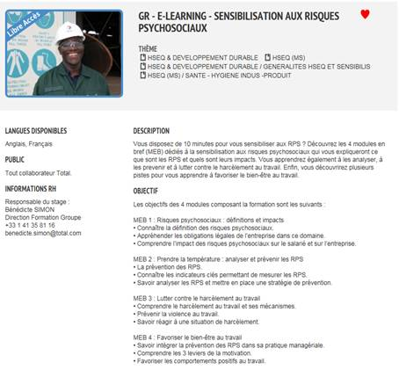)

- Suggestion for sequence roll-out
Instructions legend for the trainer:
- Comments for the trainer
- Key content elements
- Type of activity
- “Question to ask”/statement of instructions

Phase/Timing | Trainer | Module content suggestion
1. Introduction and objectives  5 minutes | Welcome participants and present the module objectives.  We will start by reviewing Total's aim for RPS together, then look at those that apply to our activities, locally. The RPS e-learning material will be followed throughout this module. | Example of an objectives overview slide:  After reminding participants of the importance of the Total Group's RPS, at the end of the module you:  - will be reminded of the Total RPS policy  - will know what is done on-site as regards RPS  - will understand your duty to report.
2. Reminder of the Total RPS policy  5 minutes -> 10 minutes | The aim of this sequence is to quickly remind participants of the importance that Total places on RPS, and what is implemented in relation to the Group's policy.To do this:  - Question/answer then show the slides to sum up  “Who can remind us of what we mean when we talk about RPS? What is it that is important to Total?”  - Slides to sum up: | Present the slides taken from TCG 2.5.
3. Follow the Group's e-learning on RPS  45 minutes -> 55 minutes | Organize it so that everyone can follow the e-learning, or do it together (display it on the video projector and read out the quizzes yourself) if you do not have the equipment to work on it individually.  Once displayed, ask:  - "what do you want to take away from the RPS?"  Organize a discussion on participants' opinions. | “RPS awareness” e-learning
4. Site/subsidiary actions regarding RPS  10 minutes - > 1 hour 05 minutes | The aim of this sequence is to establish the link with the site/subsidiary's roadmap and to present what the site/subsidiary does in this respect. In particular:  - Current and future actions.  - Problematic situations that can potentially be avoided  - Provisions in place  - The points of contact (occupational physician) | Slide on site/subsidiary actions
5. Summary  25 minutes - > 1 hour 30 minutes | The aim of this sequence is to help participants realize what relates to them directly in their line of work and which points to watch out for.  Ask participants to take some time to note down the answers to the following questions:  - "What is your specific role?  - What difficulties do you envisage in carrying out your role?"  Organize a quick round table discussion on the answers.  As a trainer, ensure that everyone understands that, at a minimum, their role is to be vigilant of others and to report if in doubt.  Go around the table one by one and write the difficulties on the board.  Once finished, come back to the difficulties one at a time and ask the group to suggest solutions, involving the speaker as well.  Thank the participants and conclude.

