Information Security and Travel-related Security

Reminders of this module's objectives:
At the end of the module, participants:
- Will know the main information security risks as regards office activities
- Will know the main security, travel and mission risks abroad and be able to inquire about the specific provisions to be made depending on the travel destination.

This document is the trainer guide. You can follow it because it contains all of the elements that will enable you to lead such a module, namely the instructions for exercises, accompanying Powerpoint references and/or various resources such as films, e-learning, etc., the questions to ask participants, the exercises to be completed if necessary.

Estimated duration: 0:50 (or 02:50 with the 2 e-learnings)

Teaching methods: In-class presentation.

Prerequisites: none.
Note: the information security e-learning modules (4 in Sept.) will be released. They will replace this module (for the information security part).
Their topics: Detecting and dealing with Phishing, managing removable devices, protecting information during travel, protecting yourself from internet dangers.

Important points for preparing the sequence:
Before beginning this module, we recommend you ensure:
- You have enough copies of “My Health and Safety at Work” booklets for participants.
- You have access to the “document retention” e-learning
- The “Travel Security” e-learning is in English.

Welcome the participants:

Welcome to this module, which deals with risks related to information security as well as travel and missions, especially abroad.
Before beginning, let's look together at the objectives of this module and how it is rolled out.
Show slide 2.

We will look together at the main security risks in office activities, and the main security risks when traveling and on missions abroad. Finally, we will look at how to find out about specific arrangements to be made according to travel destinations.
Ensure that the contents are clear to everyone.
Answer any potential questions.

5 minutes 00:05

Sequence 1:
The aim of the sequence: participants should understand that the risks related to information security are numerous and important.

I would like to begin with information security, or, to be more precise, Informational Assets (IA). Do you know the definition?
Ask participants to give a definition and then clarify if necessary by explaining that "The Informational Asset is the information, data and knowledge held by an organization that has a positive value."
For a company such as TOTAL, the risks can be significant, concerning sensitive data on strategy, sales-acquisitions projects, geological analyses, etc."

5 minutes 00:10

Here are some cases and figures related to IA.

Show slide 3.

Then ask participants: “In your private life, have you faced information security issues? (Phishing, hacking, etc.).”
Let the participants tell their stories and at the end, ask them what they have done to prevent this from happening again.

To ensure that it is clear to everyone, ask participants to summarize their understanding of the IA and the risks associated with IA. Clarify if needed.

To reinforce this further, we are going to watch a video that shows the majority of risks related to Informational Assets. It is a bit dated (from 2006), but the underlying messages are still relevant.
It lasts 15 minutes. I would like you to note the key points that you think are the most important, and we will put them together after the video.
Show the video: (“la_surete_est_votre_responsabilite.wmv” [Security is your responsibility])

15 minutes 00:25
Sequence 2:
The aim of the sequence: participants should understand that information security is only effective with everyone's participation.

Let's look together at what important points you have noted (in the film)

Ask a volunteer to write the key points on the board.
Ask the other participants to complete the list if necessary.

If there are any questions, rephrase then try to get the group to answer. Only answer if the group is not able to do it.

Once completed, congratulate the group and establish the link with the following summary slide.

Introduce slide 4 by emphasizing the participation and vigilance required from everyone: the human being is often the "weakest link" in information security.

15 minutes 00:40

We have mentioned the term “sensitive information”.
In fact, not all information has the same confidentiality level. Here are the 5 confidentiality levels, defined by Group security directive 010 (Security booklet).

Show slide 5.
Ask whether the classification is clear, and answer any potential questions.

5 minutes 00:45

1/
Ask participants to complete the e-learning on the document retention policy (1 hour 30 minutes): http://clickandlearn.total.com/portail/idea/?k=conservation

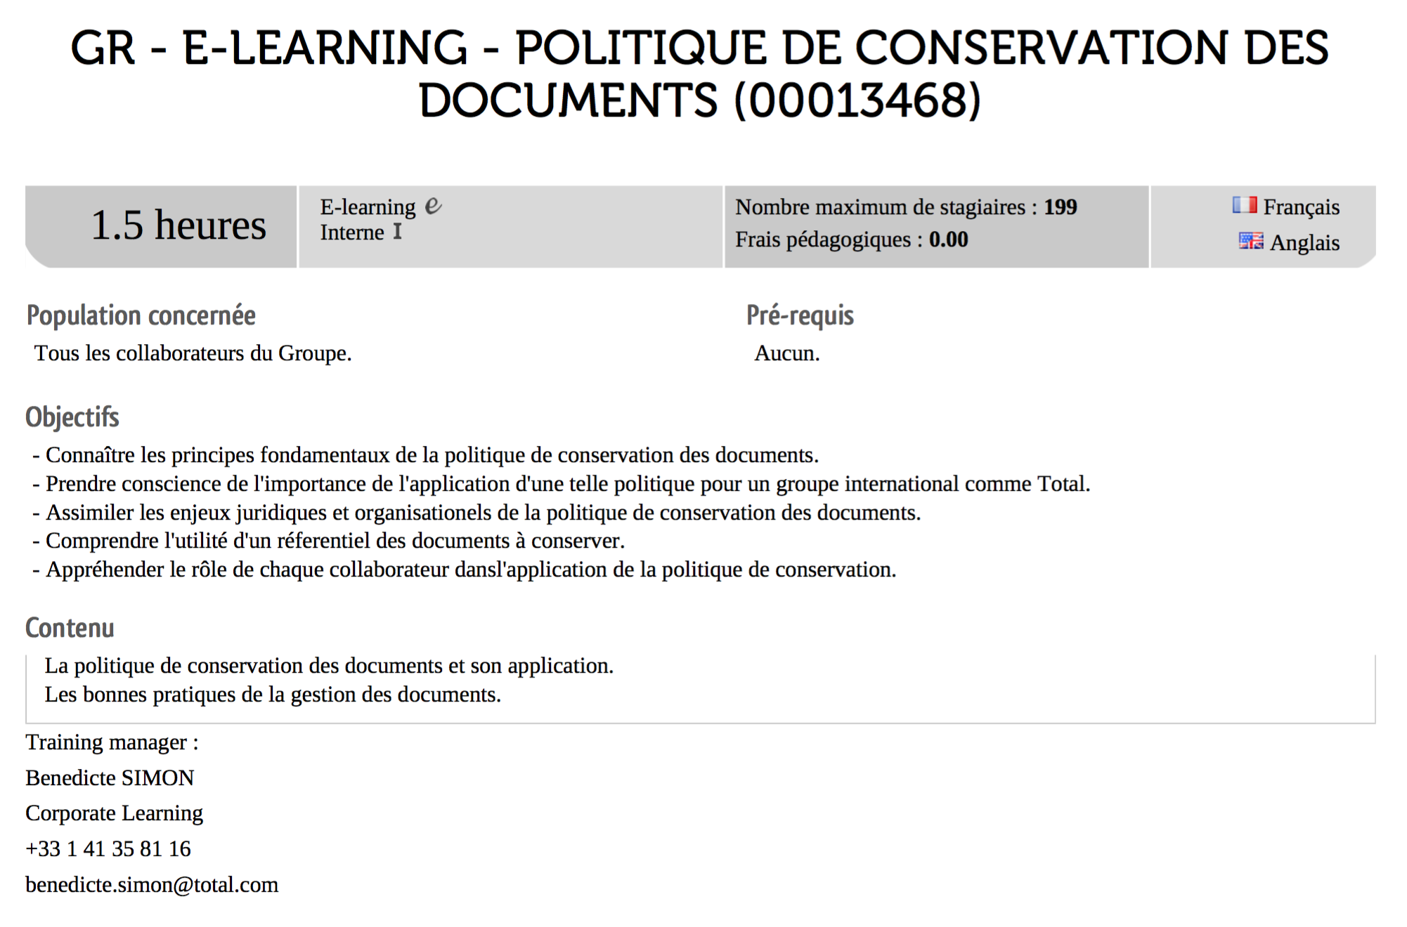

90 minutes 02:15

2/
To provide more in-depth information on document retention, present the slide on the Group's IT regulations.

Show slide 6 and ask a volunteer to read it aloud.

SECURITY BOX: an encryption tool used by the Group to protect sensitive information by making it illegible for those who do not need access to it. Ask your IT support to install the Security Box software (provided by the Group).

Same for slide 7, then ask the group to make a summary.

5 minutes 0:50

Debriefing:
What did you retain?
What seems difficult about it?
What will you introduce?

Sequence 3:
The aim of the sequence: participants should understand that before leaving on a mission, they must inquire about the security conditions.

Complete the e-learning on Travel-related security (available in English only).

Distribute the "Travel to high-risk countries" brochure and ask participants to keep it and read it carefully when needed.
If the brochure is not available, tell participants how to access it on the intranet, so that they are well informed before going on a mission.

