Positions and Postures (at the office)

Objectives:
At the end of the sequence, participants:
- Will know the main risks related to occasional load handling (offices, shelves in service station)
- Will know the basic rules for handling loads.
- Will be able to identify a load handling situation that requires the use of specific equipment and to use it if necessary.

This brick is to be built locally. To this end, 3 options are available to you:
- either a local (or division) training exists and meets these objectives. In this case, it can be used instead of this module.
- or a “Positions and postures” film is available, and meets these objectives. In this case, it can be used instead of this module if it is completed with a debriefing.
- If training or the film is not available, you must build your own training session by following the suggestions below.
This document contains content suggestions and educational activities to achieve the goals of this module. All the contents included in this suggestion are available in the resources.ppt document attached to this guide.

Key elements | Support/activities
The “positions and postures” risks are mainly musculo-skeletal risks (dorsolumbar strain, in the long-term). | Introduction powerpoint (if necessary)
To prevent these risks, an appropriate posture must be adopted for the current activity. | Introduction powerpoint (if necessary)
Objective of local training:  At the end of training, trainees:  - Will know the dorsolumbar risks and how to prevent them,  - Will know how to apply appropriate work position and posture techniques to reduce the frequency of accidents, reduce fatigue and improve professional competence.  - Will know how to identify a load handling situation that requires the use of specific equipment and know how to use it if necessary. | Local training

Estimated duration: 01:40

Teaching method recommendations:

After introducing the "Positions and Postures" risks and their consequences to the human body (particularly the dorso-lumbar area), participants are asked to practice some basic positions to prevent hazards.

- Pre-requisite modules for the sequence
- E-learning on golden rule no. 3

- Preparing the sequence
Before beginning the module, we recommend you:
- ensure that practical training at the end of this module is ready (exercises, dummy loads available).
- Suggestion for sequence roll-out
Instructions legend for the trainer:
- Comments for the trainer
- Key content elements
- Type of activity
- “Question to ask”/statement of instructions

Phase/Timing | Trainer | Module content suggestion
1.  Welcome  5 minutes 5 minutes | Welcome and objectives  Welcome participants and present the objectives of this module.  Specify that this first theoretical part will be followed by practical workshops.  "Let us start with a reminder. You all know golden rule no. 3 "Positions/postures/tools", since you have followed the e-learning.  In this module, we will go into positions and postures in a little more detail." | At the end of this module, you:  - will know the main risks related to occasional load handling (offices, shelves in service station),  - will know the basic rules for handling loads.  - will be able to identify a load handling situation that requires the use of specific equipment and to use it if necessary.  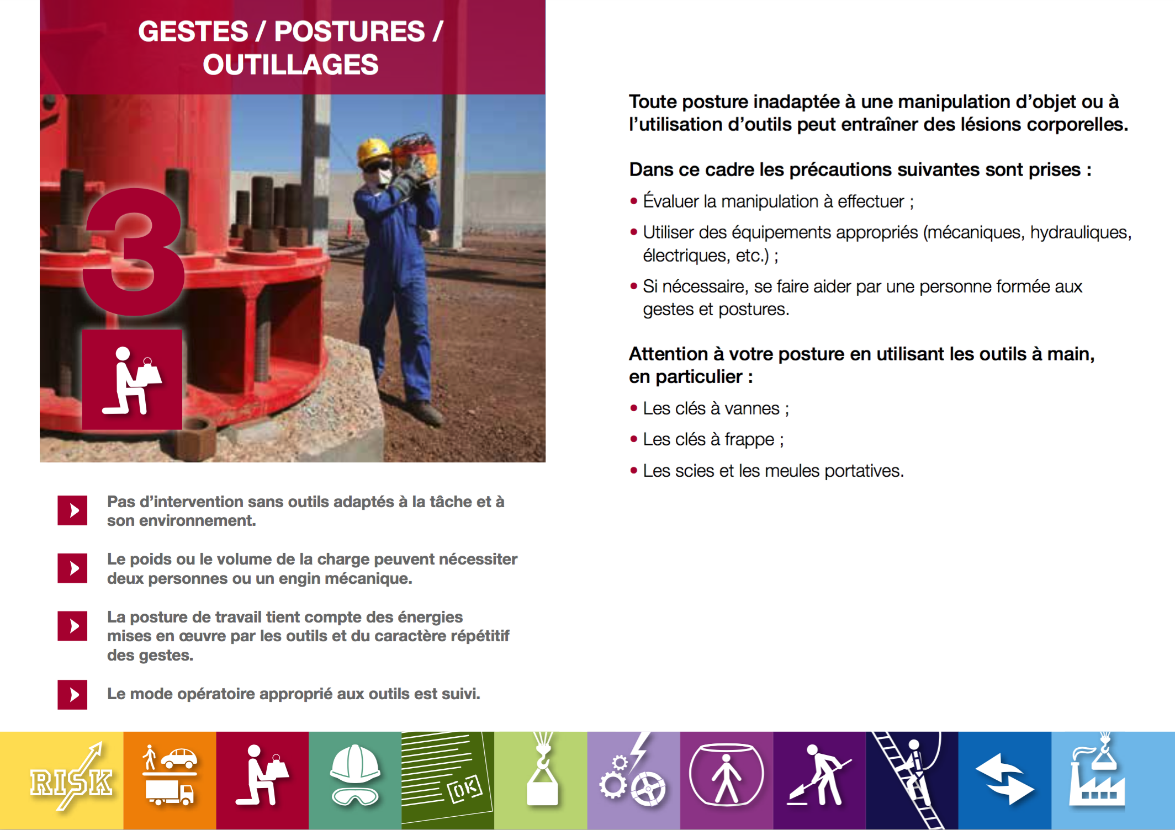
2.  Positions and postures: Protect your back.  5 minutes 10 minutes | Position and posture risks  Using aspects of the attached content, create one or two slides to explain the dorso-lumbar risks.  Have participants read the slide content and ensure it is clear to everyone. | Resource slides 3 and 4.  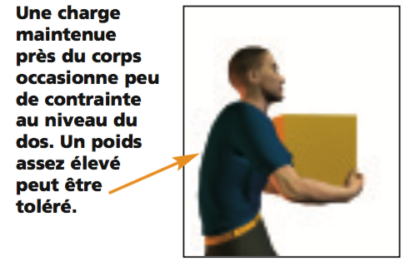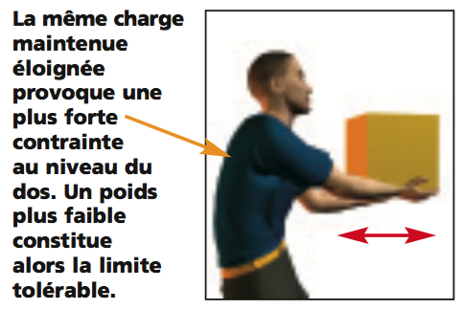  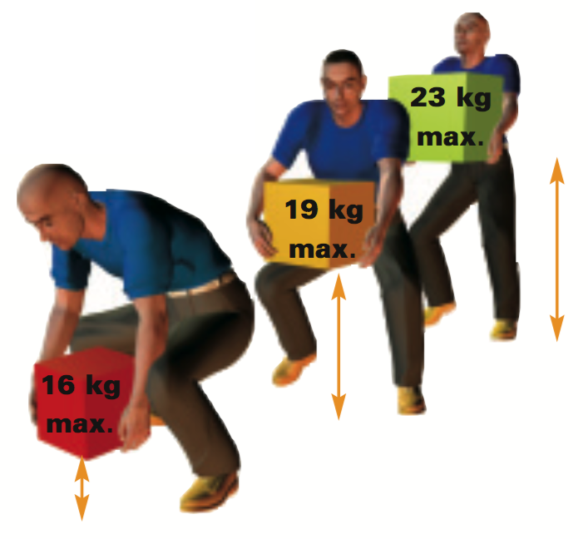
3. Positions and postures exercise  10 minutes 20 minutes | Exercise  Use illustrations to create an exercise in which participants identify the right/wrong posture.  Show the slide and ask  "For each situation, tell us if the posture is correct or incorrect and why?"  Finally, illustrate with other examples or specific situations that are in the participants' surroundings. | Picking up a heavy object on the ground or cushioning a fall  NO: rounded back, legs stretched  YES: loading the object on a thigh reduces stress on the spine  YES: bent leg, flat back, close to the load  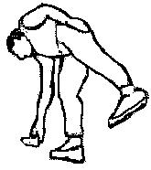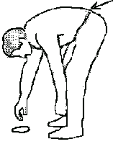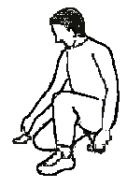  YES: for very light objects, keep the leg stretched for balance  NO: rounded back, legs stretched  YES
4. Position at the workstation.  5 minutes -> 25 minutes | Position at the computer workstation  "“Let's now talk about your position at the workstation."  Present the slide on the optimal posture in the office.  "A prolonged bad position in front of a screen can be harmful to your back, and other areas (eyes, grip, shoulders, etc.)"  Among these recommendations, what are those:  - that you have already applied  - that you find difficult to apply? | For an optimal posture in the office  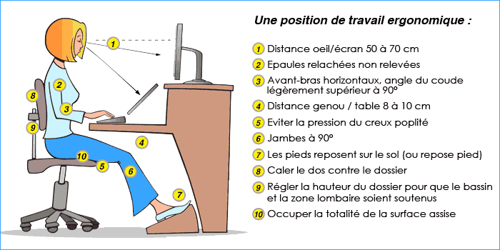
5. Put into practice  1 hour 15 minutes -> 1 hour 40 minutes | Practical exercises (to be organized by the site/subsidiary).  To apply these aspects, organize a convenient time for each participant to handle dummy loads.  Create simulations with participants. Those who observe give their opinions on what is good, and what should be improved.  Check that the instructions given during the module are followed.  In conclusion: Remember that muscolo-skeletal risks are not insignificant: they can lead to serious and detrimental injuries in the long term.

