Stop Card (On-site Exercise)

Objectives:
At the end of the sequence, participants:
- will have tried out the Stop Card in the office activities.
- will have debriefed with their N+1 on its use and the difficulties encountered.

This module is to be built locally. To this end, 2 options are available to you:
- either a local (or division) training exists and meets these objectives. In this case, it can be used instead of this module.
- if this is not the case, you must build your own training session by following the suggestions below.
This document contains content suggestions and educational activities to achieve the goals of this module.

Key elements | Support/activities
Should a dangerous situation occur, the Stop Card opens a dialog on the situation so that the risks can be understood and, if required and only afterwards, the Stop Card can be used to halt work.
The Stop Card is also to be used in offices

Estimated duration: 01:00 (excluding the on-site exercise and debriefing)

Teaching method recommendations:

Interactive presentation with the on-site exercise and debriefing with N+1 (half day)
- Pre-requisite modules for the sequence
- TCG 5.4 (Stop Card)
- Preparing the sequence
Before beginning the module, we recommend you:
- ensure that each participant has received their Stop Card.
- adapt the “StopCard_Présentation_réunions-formation_FR.pptx” [StopCard_Presentation_meetings-training] presentation for offices.
- have a copy of the <StopCard_FPA_Exemples-utilization_hors-ops-industrielles_FR.pdf> [StopCard_FPA_Examples-use_excl-industrial-ops] file to run the simulations.
- Ensure the availability of N+1s for the debriefing and that they know what is expected of them (to promote Stop Card use and safety discussions).
- Suggestion for sequence roll-out
Instructions legend for the trainer:
- Comments for the trainer
- Key content elements
- Type of activity
- “Question to ask”/statement of instructions

Phase/Timing | Trainer | Module content suggestion
1.  Welcome  5 minutes 5 minutes | Welcome and objectives  Welcome participants and present the objectives of this module.  Clarify that this first part in the classroom is primarily used to create a framework for the on-site exercise. | At the end of this module, you:  - will have tried out the Stop Card in the office activities.  - will have debriefed with your N+1 on its use and the difficulties encountered.
2.  The Stop Card  10 minutes 15 minutes | Start with a reminder, by presenting the main points of the Stop card and its use.  These 3 slides are available in the “Ressources.pptx” file  Ask whether everyone has received their Stop Card, and if they have had occasion to use it:  If yes: Can you describe the circumstances to us and how the other person reacted?  If no: In line with what we have just seen, how should you intervene? | 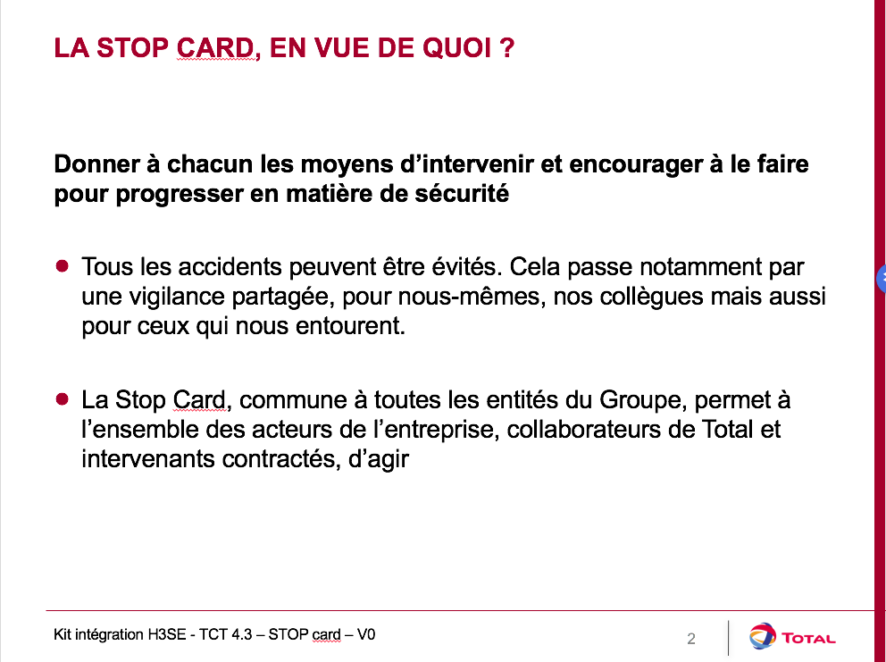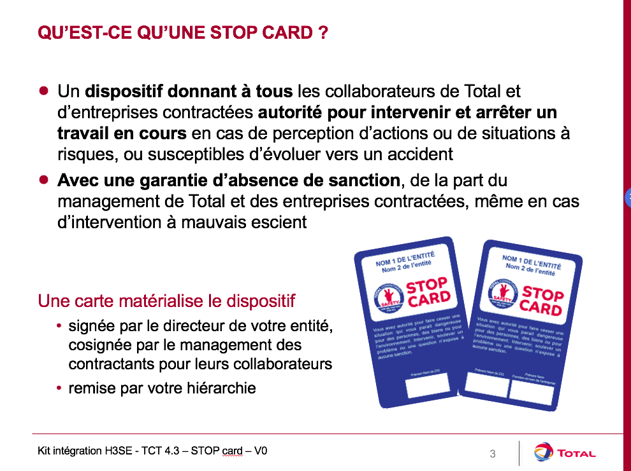  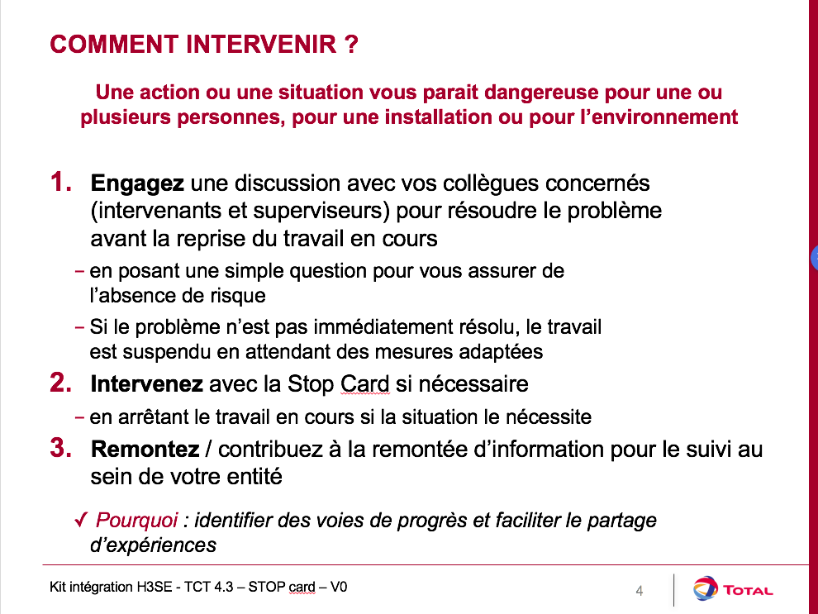
3. Safety observation  5 minutes 20 minutes | To intervene, before using the Stop Card, it is advisable to carry out a safety observation. | What is a safety observation?  It is a simple, open discussion which allows you to (potentially) introduce the Stop Card.  It enables you to make contact with the person by asking them appropriate questions to check that they are aware of the potential risk that they are taking.  Before intervening, you should analyze the context so you can decide on the most appropriate moment to intervene. Depending on the circumstances:  - the intervention must be immediate;  - the intervention may be performed in public, or else in private to avoid the risk of stigmatization.  An intervention must always be conducted in a friendly and open-minded manner.  This means you must always begin by assuming that you have observed or understood the situation incorrectly, and only then should you question the person. It is important to avoid giving the person the impression that they are at fault by using words that will establish mutual respect, which will pave the way for the right questions to be asked.  The guiding principle of an intervention is to investigate the causes of inappropriate behavior and to discuss the consequences of this behavior.
4. The situations in which to use it  10 minutes 30 minutes | Ask:  “What risk situations do you think exist in offices?  In which you should use it?"  Summarize participants' answers, then establish the link with the following exercise. | Overview slide presenting potential situations in offices (to be adapted according to the site/subsidiary)
5. Train yourself to use it  25 minutes 55 minutes | Simulation  Use the illustrations proposed in the <StopCard_FPA_Exemples-utilization_hors-ops-industrielles_FR.pdf> [StopCard_FPA_Examples-use_excl-industrial-ops] file  For each illustration:  Ask 2 people to role play the situations (change people for each situation).  To do this:  - Present the situation in a few words  - Ask 2 people to role play (one person using their Stop Card).  - Once the role play is complete, ask what is correct/in compliance with Stop Card use.  - Then ask the others to suggest improvements.  - Finally, read the “solution”  As trainer, ensure that you start with the positive points.  Once the role plays are finished, ask participants to summarize Stop Card use, specifying the potential difficulties in applying it. Should applying it be difficult, look for solutions together.
6. On-site exercise  During the month of integration | Present the on-site exercise:  - The objective is to use the Stop Card during the on-site exercise period.  - at the end of the on-site exercise, a debriefing with N+1 is organized.  - the debriefing consists of a discovery report.  Show the slide specifying what is expected of participants and answer any potential questions, then plan the dates. | Contents of the discovery report - Stop Card  Under which circumstances have you already intervened with the Stop Card?  How did the person react?  What surprised you the most?  What did you ascertain from your intervention? And the use of the Stop Card in general?
Debriefing with N+1  30 minutes | Debriefing  At the agreed upon date, organize the debriefing with N+1 using a round table discussion focusing on the following points:  - A quick description of the initial situation  - What did you do?  - How did the person react?  Summarize the usefulness of the Stop Card and the safety discussions.  Thank the participants and N+1.

