The Top 5 Accidents Linked to Violation of the Golden Rules

Objectives:
At the end of the module, participants:
- will be aware of the most frequently broken golden rules which have resulted in fatal accidents: on a Group level and on a site/subsidiary level.

This sequence is to be built locally. To this end, 2 options are available to you:
- either a local (or branch) training exists and meets these objectives. In this case, it can be used instead of this module.
- if this is not the case, you must build your own training session by following the suggestions below.

This document contains content suggestions and educational activities to achieve the goals of this module.

Key elements | Support/activities
The most frequently broken golden rules which have led to fatal accidents on a Group level
The most frequently broken golden rules which have led to fatal accidents (or HIPO) on-site. | - Description of a fatal accident on-site related to non-compliance with a golden rule.  - Option of feedback video (see H2S accident at Lacq)  - Option of reading the description of an accident from the site/subsidiary's reporting database.

Estimated duration:
30 minutes to 1 hour

Teaching method recommendations:
In classroom with a study of actual situations.

- Pre-requisite modules for the sequence
- TCG 5.1
- Golden Rules e-learning modules.
- Preparing the sequence

Before beginning the module, we recommend you:
- select 2 actual situations (accidents which resulted in deaths) to study (1 which relates to the Total Group, and 1 specific to the site/subsidiary).
- Suggestion for sequence roll-out
Instructions legend for the trainer:
- Comments for the trainer
- Key content elements
- Type of activity
- “Question to ask”/statement of instructions

Phase/Timing | Trainer | Module content suggestion
1. Introduction and objectives  5 minutes | Welcome the participants and present the sequence objectives.  At the end of this module, you will have a good idea of golden rules that were broken and led to fatal accidents.  Make it clear that this involves fatal accidents: Group and site/subsidiary. | Example of an overview slide for the objectives and roll-out:  At the end of the sequence, you will be aware of the most frequently broken golden rules which have resulted in fatal accidents: on a Group level and on a site/subsidiary level.
2. Reminder of the Golden Rules  5 minutes -> 10 minutes | Introduction  Ask everyone to remind us in what context the golden rules were set up and what they are used for.  In summary, show two slides on their origin and the golden rules themselves. | Example of overview slides on the origin of the golden rules  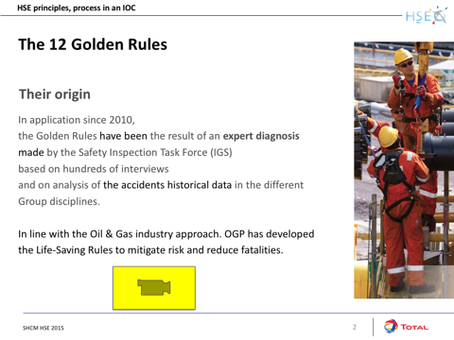  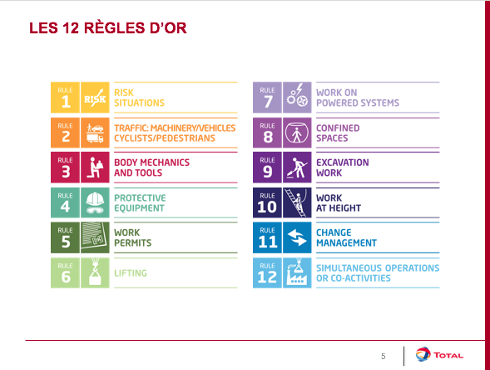
3. The most frequently broken golden rules and fatal accidents  15 minutes -> 25 minutes | Actual situation (Total Group)  Show the actual situation.  Ask participants to identify whether one or more golden rules have not been complied with.  Start a round table discussion so that each participant can talk about the rule they think is most frequently involved in accidents following a golden rule violation. | Slide with the description of a fatal accident related to non-compliance with a golden rule.  Slide with the distribution of Group accidents over the 2010 - 2016 period  - Accidents with actual consequences > or = 4  - HIPO with potential consequences > or = 4  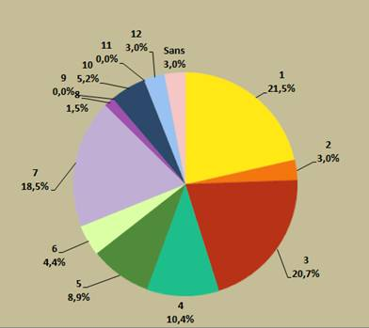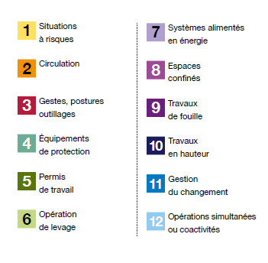
4. The most frequently broken golden rules and fatal accidents on-site  35 minutes - > 1 hour | Actual situation (Site/subsidiary)  This sequence, as with the previous one, is intended to draw participants' attention to the fact that "this just doesn't happen somewhere else".  Ask participants to identify whether one or more golden rules have not been complied with in this situation.  Specify why this rule in particular, and possibly establish the link with the site/subsidiary specificities.  Ask participants if they have an idea of the broken rules that have resulted in the most accidents on site.  Transposition  Finally, what about you?  - In your opinion, is this likely to happen again? Under what circumstances?  - What have you learned from it? What do you want to retain, what should you take into account specifically in your work so that such accidents do not happen again?  - You will visit the site again, this time to observe the application of the golden rules. What are you going to do, especially for the ones we just saw?  Leave time for participants to think about it, then start a round table discussion. | Slide presenting a HIPO or a death on-site caused by non-compliance with a golden rule (find an accident involving the rule that is most frequently broken on-site).  (search the reporting software used by the site/subsidiary).  Slide with three questions:  - Is this likely to happen again?  - What are the lessons you want to keep in mind so that such accidents do not happen again?  - You will visit the site again, this time to observe the application of the golden rules. What are you going to do, especially for the ones we just saw?

