Works Process and Work Permit

Objectives:
At the end of the module, participants:
- Will understand the Group regulations on works.
- Will understand all of the steps in the implementation process for works on the site/subsidiary: from the description of the requirement to payment of the contractor performing the work.
- Will understand the steps in the site/subsidiary's work permit process (prioritization of opinions, validation, coordination, planning, preparation, implementation and handover)
- Will know how to convey the key points for each of them (particularly the importance of a description and risk analysis of works to be completed).
- Will be able to use the site/subsidiary's work authorization supports.
- Will have taken part in running the work permit system on-site
- Will have led a work authorization audit on-site

This sequence is to be built locally. To this end, 2 options are available to you:
- either a local (or division) training exists and meets these objectives. In this case, it can be used instead of this module.
- if this is not the case, you must build your own training session by following the suggestions below.

This document contains content suggestions and educational activities to achieve the goals of this module.

Resources are available in the PowerPoint related to this module to help you build the module.

Key elements | Support/activities
The local itinerary is provided as a suggestion. But it is important that the following messages are understood:
- The site/subsidiary's work permit regulation (so that they can refer to it if in doubt)
- The permit process in its entirety: steps, responsibility
- The key points of the steps: description - > specify, risk analysis - > divide out the task and assess the risk.
- The connection between the production and maintenance service
- The forms/supports used on the site/subsidiary (work permits and additional permits): aim and what types of work are relevant.
- The points to be checked during a work permit audit
The on-site exercise is mandatory, as is the debriefing.

Estimated duration:
2 days.

Teaching method recommendations:
In the classroom/workshop (1 day) to study the Work Permit principles, then one day on-site to follow the Work Permit system and perform an audit on the Work Permit.
- Pre-requisite modules for the sequence
- TCG 4
- TCAS 4
- The 12 Golden Rules

- Preparing the sequence
Before beginning this module, we recommend you ensure:
- That there are enough printed copies of the Branch regulation on the Work Permit and the site/subsidiary regulation.
- That you have enough printed copies of the "Work Permit" audit framework for all participants.
- That the implementation procedures for day 2 are in place: the date, information on the people on-site who will be shadowed by the “newcomers”, that all newcomers have a point of contact, etc.

- Suggestion for sequence roll-out
Instructions legend for the trainer:
- Comments for the trainer
- Key content elements
- Type of activity
- “Question to ask”/statement of instructions

Phase/Timing | Trainer | Module content suggestion
1. Introduction and objectives  5 minutes | Welcome participants and present the module objectives.  The aim is for you to be aware of the way in which works are completed on-site and their relevant permissions, the Work Permit or Work Authorization. No on-site work is permitted without work authorization.  This module is composed of 2 parts: one day in the classroom; today this involves the main points and a second day for on-site follow-up of the points reviewed during the first day.  Ask whether participants already have experience with the Work Permit on-site. (you will thus be able to focus on them) | Example of an objectives overview slide:  At the end of the sequence:  - You will understand the Group regulations on works.  - You will know all of the steps in the implementation process for on-site works.  - You will be able to convey the key points for each of them (particularly the importance of a description and risk analysis of works to be completed).  - You will be able to use the site/subsidiary's work authorization supports.  - You will have taken part in running the work authorization process on-site and will have led a work authorization audit on-site.
2. Know the main points in the Branch reference document  40 minutes -> 45 minutes | The aim of this sequence is to read and understand the Branch reference point (or the Group Directive).  To do this:  - Start by asking: In view of your experience and the aspects looked at in HSE integration course modules, how do you think the works present significant risks? In particular at Total?  Show the slide to sum up.  - Simplyremind them that works are subject to a golden rule (no. 5) and a Group regulation that is shared by all business units (Refining, Chemicals, EP, MS), i.e. DIR GR SEC 022 and a resultant Branch regulation. And that these rules provide the principles for everyone to follow within the works framework.  Read the slide.  - Workshop on the Branch regulation.  Distribute the regulation and leave participants for 10 minutes to read it, and ask them to note, as they are reading, the points they consider important and any gray areas.  Then ask:  - What do you think are the important points?  - Which aspects remain unclear to you?  Start a round table discussion to gather everyone's answers. (concerning the important points, don't be afraid to read through the document passages again). | Slide on the aim/origin of the work permit requirement: Activities that are not part of Total's “core business” carried out by a person to whom it is the “core-business”. The work permit makes contractors and business owners aware of the risks on-site, and makes Total aware of the workplace risks that companies will have to take.  Golden rule slide: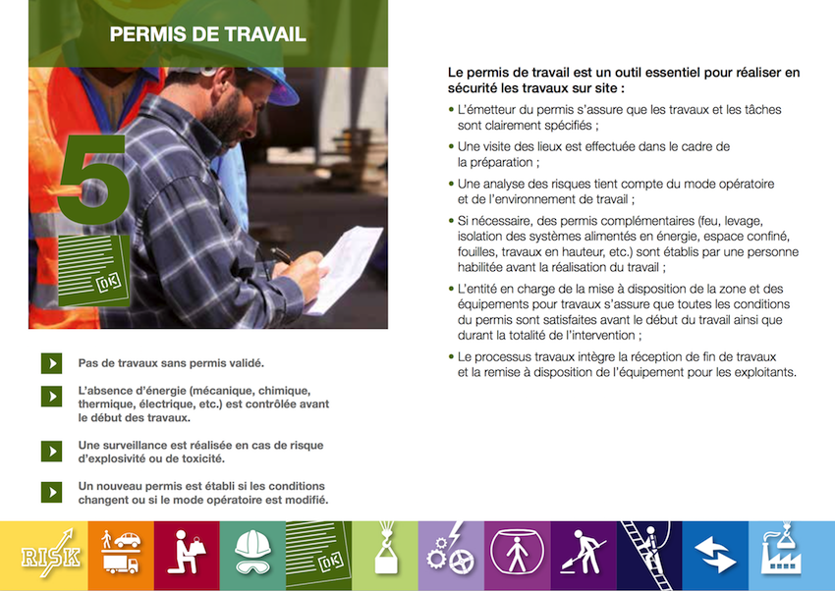
3. The works process.  30 minutes - > 1 hour 15 minutes | The aim of this sequence is to be aware of the main steps in the works process and the Work Permit.  To do this:  - Start with an exercise, asking participants to analyze the following situation in groups: If you were to refurbish your home using several different types of tradesmen (mason, electrician and plumber):  - What would the overall stages of work be?  - What arrangements would you put in place to ensure that the project is completed safely?  - If an accident occurs, who is responsible? You or the tradesmen?  Then have a group present it on the board.  During their presentation, ask the others to improve on it by adding their thoughts.  As trainer, ensure that the preparation is clearly distinguished from the execution.  - Summarize using the following slides and comments: "Execution is only one step in the works process.  Works are generally completed by companies. It is the execution part that is the most risky and requires the work permit to be correctly prepared (identification of risks and compensatory measures).  To ensure that the work is carried out safely, every effort must be made to ensure that risks are known and controlled by the contractors. It is the instructing party's responsibility to ensure this."  - Puzzle exercise.  Distribute the different steps to the groups of 2. Then ask them to put them back in order.  To correct, ask a group to present it on the board. Have the other participants comment on it.  - Present the steps of the process  Show the slide, reading the various activity stages/steps (if a generic description of the process exists for your branch, you should use it instead of this one).  Specify that the Work Permit is only part of the overall works process.  - In summary, specify that this process and the steps are shared by each branch and site/subsidiary.  Each one will adapt it according to its constraints, in accordance with the basic requirements. | Slide to display the question: If you were to refurbish your home using several different types of tradesmen (mason, electrician and plumber):  - What would the overall stages of work be?  - What arrangements would you put in place to ensure that the project is completed safely?  - If an accident occurs, who is responsible? You or the tradesmen?  Slide including the following messages:  "Execution is only one step in the works process.  Works are generally completed by companies. It is the execution part that is the most risky and requires the work permit to be correctly prepared (identification of risks and compensatory measures).  To ensure that the work is carried out safely, every effort must be made to ensure that risks are known and controlled by the contractors. It is the instructing party's responsibility to ensure this."  Slide including the following messages:  Slide: the cover page for the Work Permit regulations on-site.
4. A signature of commitment  5 minutes - > 1 hour 20 minutes | The aim of this sequence is for participants to understand that a signature is a commitment made by the person who signs it, and that everything is not necessarily alright just because the previous person has signed it.  (We shall limit ourselves to professional responsibility, to avoid getting into the legal field).  To do this: review the slide on the process and list the different signatures that are needed.  Summarize using the slide: | Slide:  - Signature = the parties agree on the work to be completed and its conditions  - Each signature is important: even if several people signed before you, your signature represents your commitment.
5. The on-site WORKS regulation  20 minutes - > 1 hour 40 minutes | The aim is for participants to be aware of the site/subsidiary regulation, a variation of the Branch regulation. To do this:  - Present the regulation and comment on its content  - Read the regulation  Organize the groups, give the instructions (read the document in pairs and note the important points and areas to be clarified) and distribute the document.  Then organize a round table discussion of the important points picked up by participants. Write them on the board. Complete them (if necessary) by re-iterating the corresponding paragraph for each additional point.  Ask whether there are any points that remain unclear and ask the other participants to answer. | Slide with the summary of the regulation.
6. The roll-out of the works process on-site and the link between the production and maintenance business units  10 minutes - > 2 hours 10 minutes | The aim of this sequence is for participants to gain an initial idea of the works process, the work permit process and distribution of activities between various departments: Production and Maintenance, HSE, Inspection, Projects.  To do this:  - Start by listing typical examples of works completed on-site (routine and non-routine).  - Present the roll-out of the works process.  - Then present the chronology and planning for implementing the work, between the various departments. Broadly-speaking, production requests a job, describes it and maintenance carries it out.  - Introduce the WORK PERMIT process, establishing the link as: "once the job is requested, it then goes back into the Work Permit process". | Slide with works process  Slide on the distribution of activities:  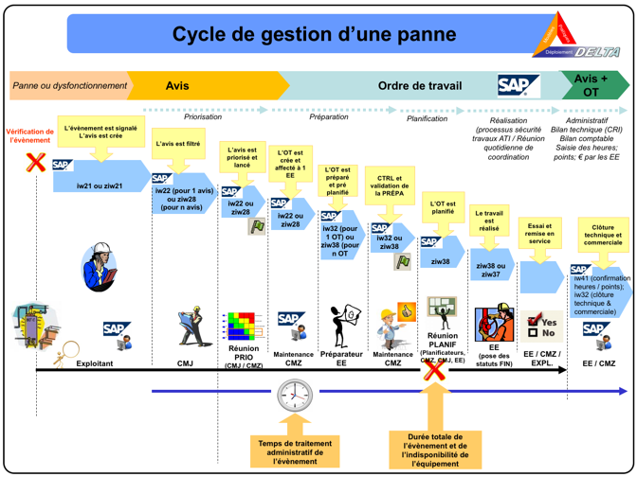  Slide on the main steps and responsibilities of the “Work Permit process”
7. Steps of the WORK PERMIT in detail.  1 hour 30 minutes -> 3 hours 40 minutes | The aim of this sequence is for participants to understand the main Work Permit steps and the key points for each one.  Focus on the main steps: Description of the problem, preparation/description of the work, risk analysis, implementation, handover & completion. Their key points are to be illustrated with examples.  To do this:  - Explain the purpose of this sequence.  - Start with the “Description of the problem, its analysis and its prioritization” step:  Remind participants of the aim of the step (to ensure that the repair is correct the first time). The work permit has not yet been issued.  Key points of the step and some best practices.  Key points: The better the description of the fault, the more effective the maintenance will be (i.e. correct the first time), to limit the requests by the instructing party in an emergency, to let maintenance organize and plan the work.  - Preparation of the work and the work permit(s)  Remind participants of the key points of the step and some of the best practices.  One of the key points is to “correctly describe all of the activities to be completed then choose the correct format depending on the work.”  So that the correct form is selected, present the various forms used on-site (open flame permit, verbal authorization, etc.) and the conditions of use.  Then organize an exercise on which form to choose using certain listed activities.  For the correct description:  Propose then provide examples corresponding to the key points (on the correct description), present good and bad examples by specifying how they are bad/description.  - The risk analysis step:  Remind participants of the key points, the method used on-site, the matrix for current on-site risks and best practices.  One of the key points is: “a risk analysis defines the precautions to be taken. The risk analysis is the summary of the risks related to the intervention of the contracted company and the Total risks related to the plants, and both parties are informed and committed.”  Then show examples of work permits with risk analyses.  Then show 3 situations in which the participants must analyze the risks using the matrix. Display 3 existing work permits, showing only the description part. Debrief.  - The step: Verification that precautions/mitigations resulting from the risk analysis are in place: present the key points.  Explain the key points: verification of the effectiveness of conditions and precautions identified in the risk analysis, just before beginning the works (last-minute risk analysis).  Then show examples of work permits with precautions.  Then show some best practices.  - The step: Execution of work.  Present the key points and best practices: complete the work, ensuring that the precautions remain in place.  This is the step to complete the audits.  In your opinion: why are the audits necessary at this stage?  (Answer: to ensure that the measures required are actually applied)  Then show bad examples/photographs. Followed by the good ones.  - The step: The handover/completion of the work carried out.  Present the key points and best practices: to check/test to resume service at the plant/workplace in complete safety, to handover the work so that the contracting company can be paid and to provide an opinion on satisfaction.  Then show examples/photographs of where clearing up has not been completed after work is complete. Followed by the good ones. | Slide: key points and best practices.  Slide: key points and best practices.  Slide: key points and best practices.  Slide with the forms.  Slide with the exercise  Slide with “good/bad” examples; description of examples from on-site Work Permits.  Slide: key points, site methods, site matrix and some best practices.  Slide with examples of the risk analysis part on some work permits.  Slide with the description part on 3 existing work permits.  Slide: key points.  Slide with work permit examples.  Slide with best practices.  Slide: key points and best practices.  Slide: examples.  Slide: key points and best practices.  Slide: examples.
8. Simulate the Work Permit process  01:00 -> 04:40 | The aim of this sequence is for participants to fully understand how the work permit process is rolled out by playing the various roles.  To do this, organize this role play.  Using the risk analysis completed, run through the permit process by giving a key role to everyone, using the regulation from your site/subsidiary (applicant/operations manager/site manager/executor, etc.).  After a short preparation time focusing on the site/subsidiary regulation and process, everyone explains what they have to do and how they would do it.  When it comes to explaining aspects of the permit to another participant (for example, the company supervisor to the executor) role play the actual discussion.  Once the simulation is completed (up to works handover) ask each participant what helped them with regard to the action or explanations of others and if they had any difficulties.
9. Work Permit audits  30 minutes - > 5 hours 10 minutes | The aim of this sequence is for participants to understand the aim of the Work Permit audits and for them to be aware of the aspects that they will have to check on-site.  To do this:  - start by announcing that during the site visit, they will have Work Permit audits to carry out on-site and that the aim of this sequence is to prepare them for this.  - Ask: "What are work permit audits for?"  Organize a discussion, noting the points on the board.  To sum up, present the slide with the essential points (ensure that the work permits are used correctly and that the precautions are well defined/in place, and above all, help with improvement).  If needed and if it exists, focus on and present the site/subsidiary regulation.  - Present the audit framework  Distribute and show it on a slide.  - List the points to be checked during an audit.  - Exercise: simulate 1 or 2 situations in which a participant (by simulation) creates an audit of an activity to be carried out by 2 other people.  The auditor uses their audit sheet.  Then, after each situation, debrief from a question phrasing and auditor's posture point of view (be careful not to be seen as an auditor but rather as someone who can help). | Slide on "What are work permits for? and the mechanism in place to implement them (program, fieldwork, framework and a debriefing at the end).  Slide with the site/subsidiary regulation (if it exists)  Slide with the audit framework.  Slide with the points to be checked.
10 Preparing for the site visit  30 minutes - > 5 hours 40 minutes | The aim of this sequence is for participants to build the site visit program, which consists of monitoring one or two work permits, and carrying out three audits.  Make it clear that a debriefing is to be carried out in the afternoon on the comments fed back by participants on the work permit process, the audit results and any surprising aspects.  Finally, ask everyone about the methods for the site visit, the debriefing time, the beginning of the work permit system, the point of contact.
Debriefing day 2  1 hour 30 minutes | The aim of this sequence is to debrief on the site visit.  At the scheduled time, ask everyone "how was the day?" (to gather a general feeling).  Then organize the order participants will present in and remind them of the points each participant must present:  - their comments on the work permit process,  - the results of the audits  - the main points of the site/subsidiary process  - the potential difficulties encountered.  Everyone quickly presents their conclusion. Don't be afraid to clarify certain points that may be unclear or to ask other participants to do so.  Thank participants for these audits.

