Positions and Postures Applied at the Workstation

Objectives:
At the end of the sequence, participants:
- Will know the risks related to the “positions and postures” inherent at their station
- Will know how to protect themselves.
- Will be able to identify a load handling situation that requires the use of specific equipment and to use it if necessary.

This sequence is to be built locally. To this end, 2 options are available to you:
- either a local (or branch) training exists and meets these objectives. In this case, it can be used instead of this module.
- if this is not the case, you must build your own training session by following the suggestions below.
This document contains content suggestions and educational activities to achieve the goals of this module.

Key elements | Support/activities
The risks linked to positions and postures are mainly musculoskeletal risks (dorsolumbar strain, in the long-term). | Introduction powerpoint (if necessary)
To prevent these risks, an appropriate posture must be adopted for the current activity, or an appropriate tool used. | Introduction powerpoint (if necessary)
Objective of local training.  At the end of training, trainees are able:  - To understand the dorsolumbar risks and how to prevent them,  - To apply appropriate work position and posture techniques to reduce the frequency of accidents, reduce fatigue and improve professional competence.  - To identify a load handling situation that requires the use of specific equipment and to use it if necessary. | Local training

Estimated duration:
1 hour 30 minutes to 2 hours

Teaching method recommendations:
After introducing the risks linked to positions and postures and their consequences to the human body (particularly the dorso-lumbar area), participants are asked to practice some basic positions to prevent hazards and to identify the specific equipment available for heavier loads.

- Pre-requisite modules for the sequence
- The golden rule no. 3 e-learning (positions/postures/tools)
- Preparing the sequence
Before beginning the module, we recommend you:
- ensure that practical training at the end of this module is ready (exercises, dummy loads available).

- Suggestion for sequence roll-out
Instructions legend for the trainer:
- Comments for the trainer
- Key content elements
- Type of activity
- “Question to ask”/statement of instructions

Phase/Timing | Trainer | Module content suggestion
1.Introduction  5 minutes 5 minutes | Welcome participants and present the module objectives.  Let's start with a reminder. You all know golden rule no. 3 "Positions/postures/tools", since you have followed the e-learning.  Let us start with a reminder. You all know golden rule no. 3 "Positions/postures/tools", since you have followed the e-learning.  In this module, we will go into positions and postures in a little more detail.  Ask:  Who can tell us what the main risks are with regard to positions and postures?  Images are available in the “Ressources.pptx” file | At the end of this module, you:  - Will know the main risks related to occasional load handling (offices, shelves in service station),  - Will know the basic rules for handling loads.  - Will be able to identify a load handling situation that requires the use of specific equipment and to use it if necessary.  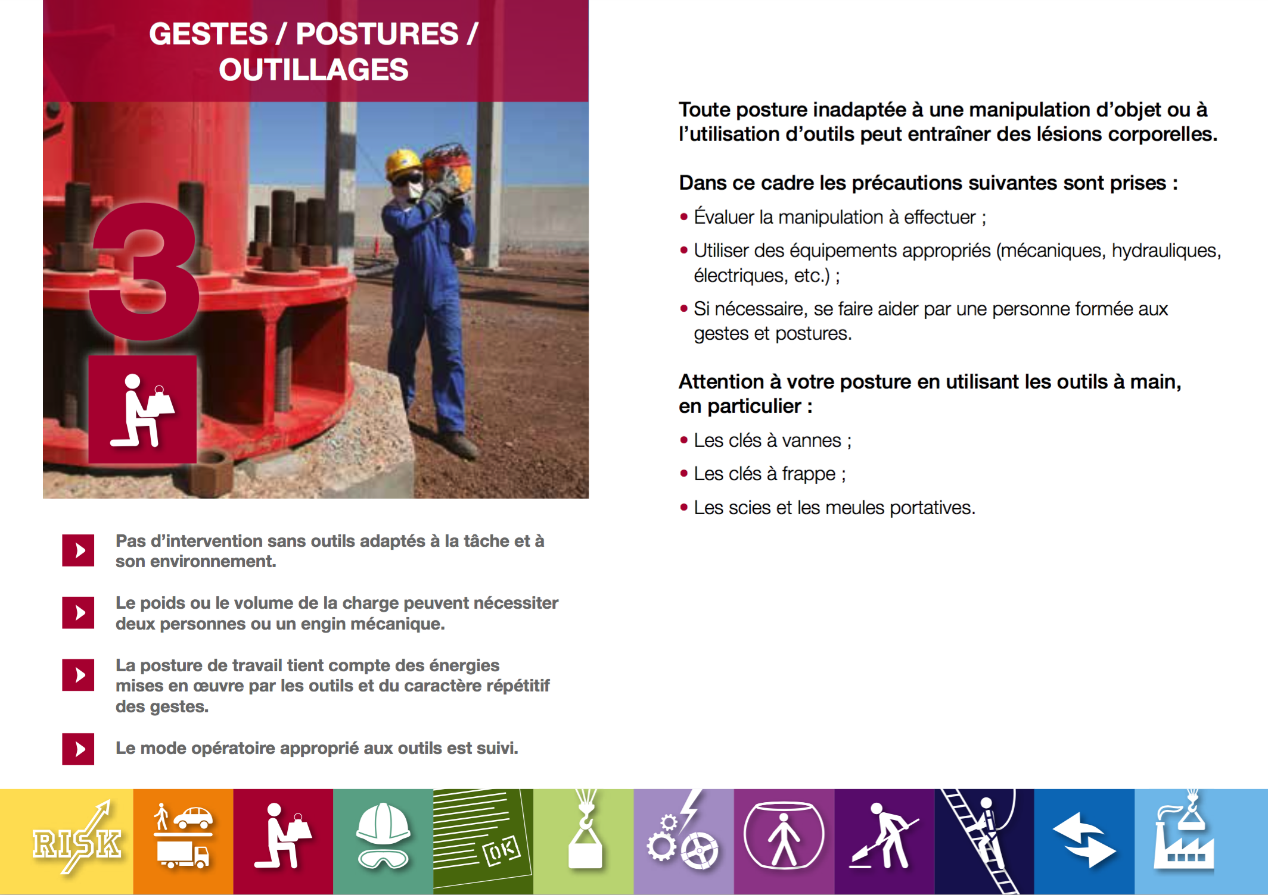
2. Positions and postures: Protect your back.  5 minutes 10 minutes | Position and posture risks  Using aspects from the attached content, create one or two slides to explain the dorso-lumbar risks. | Positions and postures: Protect your back  Among the ailments in our business, back pain is the most common.  Although back pain varies a lot from one person to another, the champion of them all is without a doubt lumbago, which affects the lower vertebrae. On the whole, 58% of injuries affect the lumbar region.  These risks, affecting the region commonly known as the “musculoskeletal” system, can bring on sudden pains, as well as cause long-term injuries.  To prevent these risks, you must adopt postures that are suited to your activities.  There is a better way to eliminate the risk: use a power tool where possible!  Each position or posture involves a certain amount of risk. Awkward postures are easiest to observe and analyze.  These types of postures are all risky for the back! For example, holding a load away from the body involves a painful posture, even if the load is relatively light.  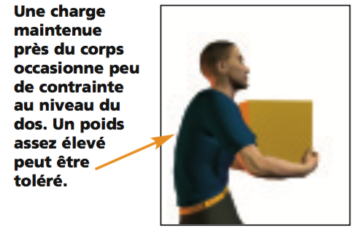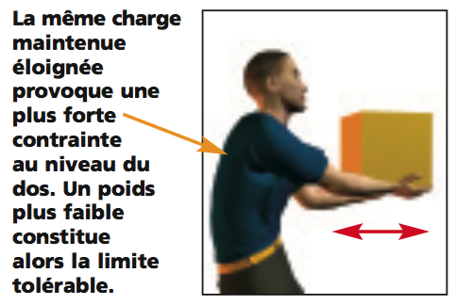  Before taking up a position, it is important to assess the effort required to achieve it. Whether you are lifting, moving or transporting a load, the goal is to match the effort required to a level that is acceptable for the back.  Example: The lower the load, the lower the weight limit:  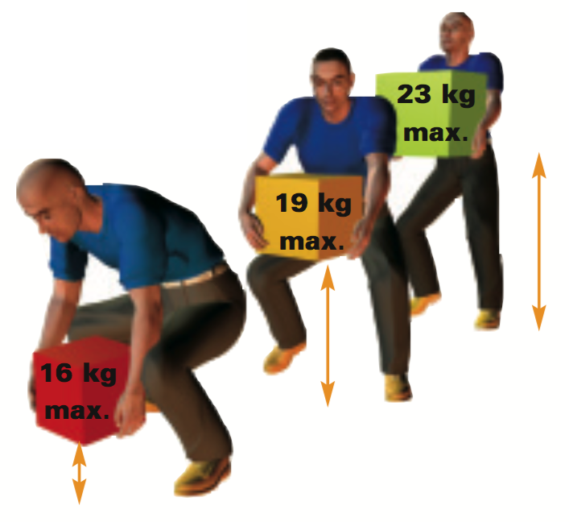  Heavy work must also be taken into account when accessibility at the workstation is limited: Example: soldering in a stooped or squatting position.  On our sites, the majority of heavy work is carried out by our contractors (maintenance and works) and you must ensure that the conditions for completing this work are in line with golden rule no. 3.
3. Positions and postures exercise  10 minutes 20 minutes | Correct/incorrect exercise  Use the drawings to create an exercise: good posture/bad posture.  You can add examples to this exercise.  Ask:  "For each situation, tell us if the posture is correct or incorrect and why?" | Slides in “Ressources.pptx” (answers appear by clicking)  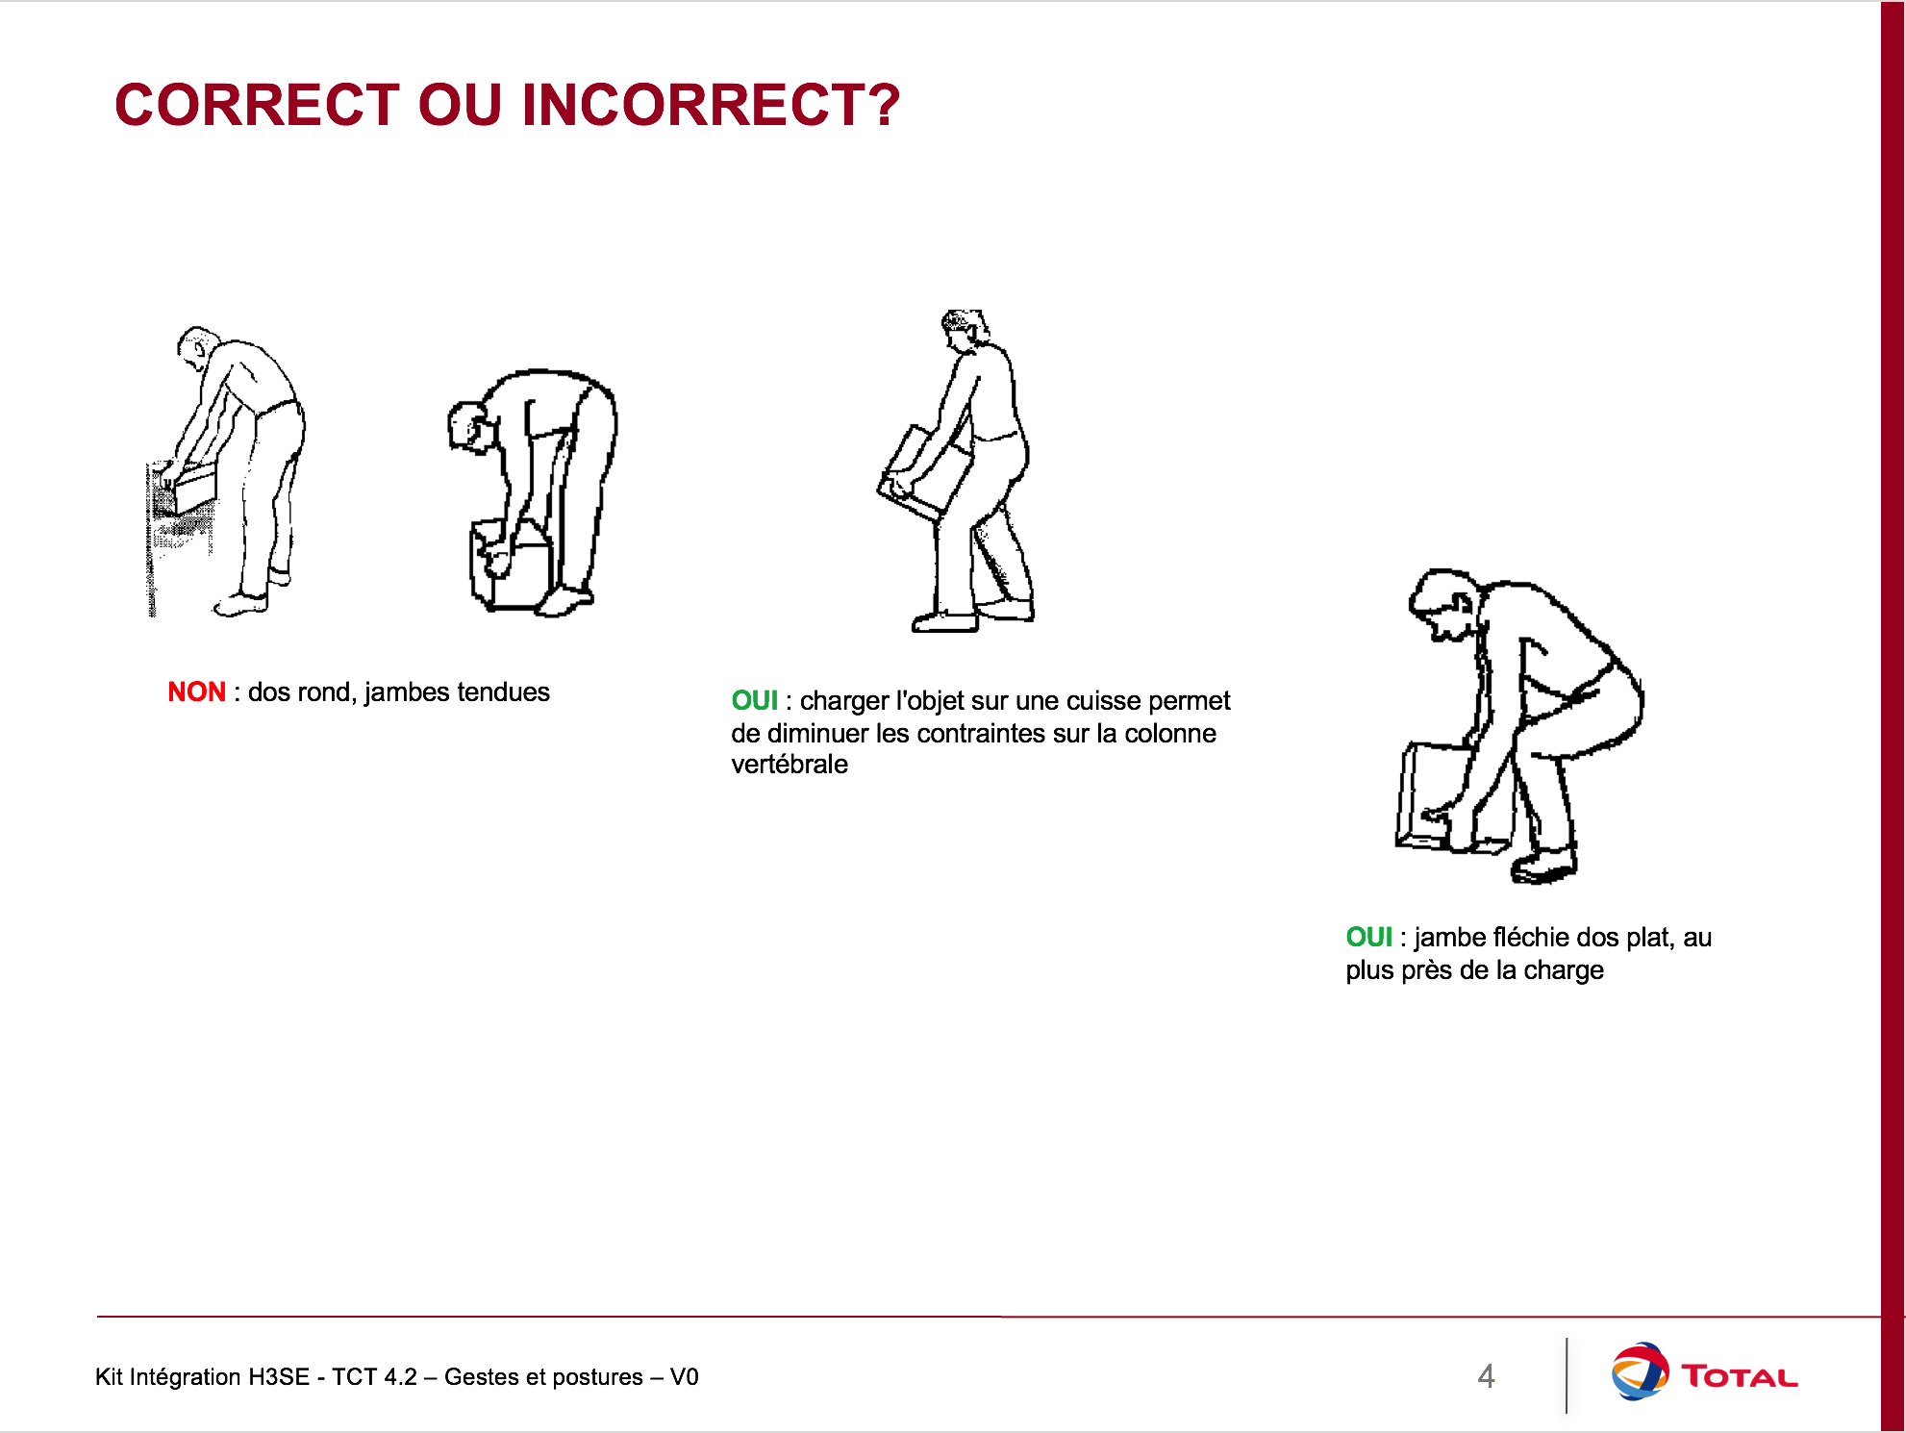  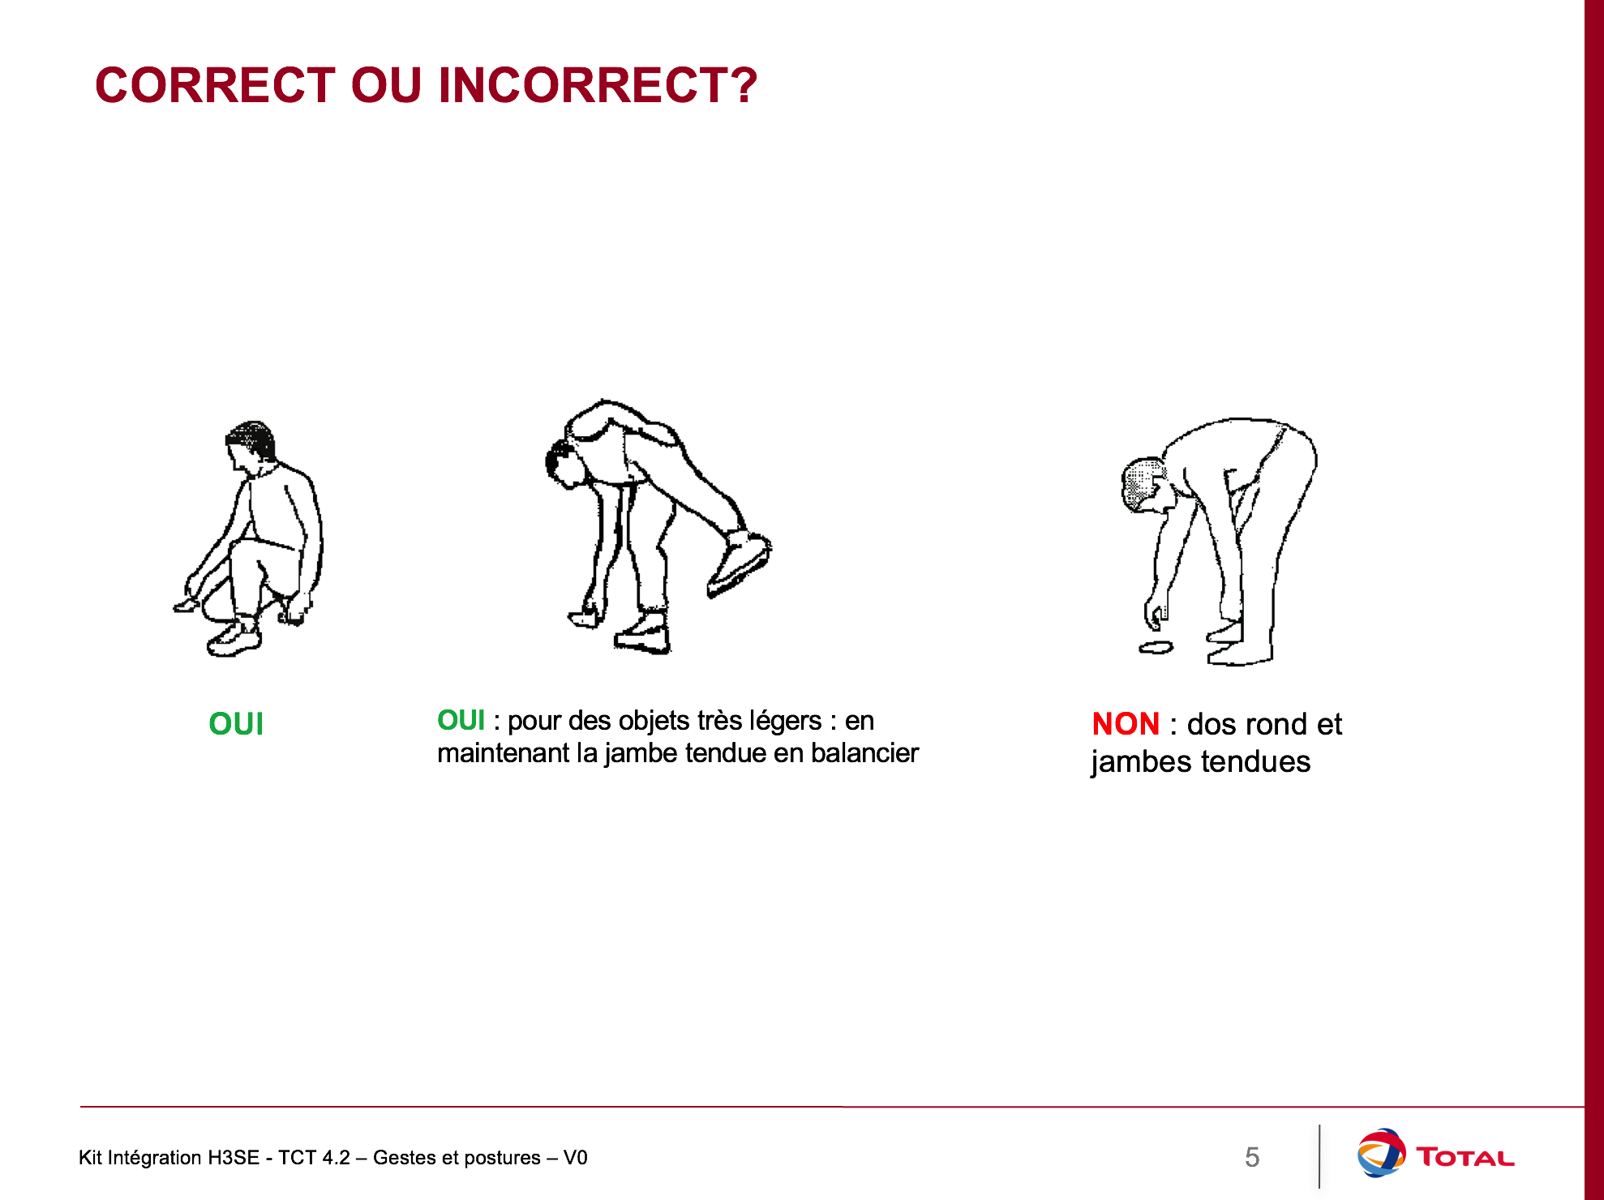
4. Position at the workstation.  5 minutes 25 minutes | Position at the computer workstation  Let's now talk about your position at the workstation.  "A prolonged bad position in front of a screen can be harmful to your back, and other areas (eyes, grip, shoulders, etc.) | For an optimal posture in the office  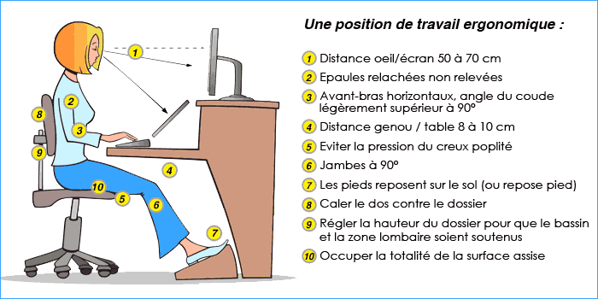
Put into practice  01:00 to 01:30  End: 01:30 to 02:00 | Organize practical training so that each participant can handle dummy loads while practicing basic risk-prevention positions.  Exercise:  Show local examples of loads that require the use of specific equipment and identify the equipment required for a given load.  In conclusion: Remember that muscoloskeletal risks are not insignificant: they can lead to serious and detrimental injuries in the long term.

