Stop Card and Safety Observation

Objectives:
At the end of the sequence, participants:
- Will be able to have a conversation about safety (safety observation) before taking out the Stop Card.

This sequence is to be built locally. To this end, 2 options are available to you:
- either a local (or branch) training exists and meets these objectives. In this case, it can be used instead of this module.
- if this is not the case, you must build your own training session by following the suggestions below.
This document contains content suggestions and educational activities to achieve the goals of this module.

Key elements | Support/activities
The Stop Card is a tool that must, above all, enable a discussion about the risks. Its use must always be preceded by a discussion about safety and will not necessarily result in use of the Stop Card.
Conduct simulations/role play for training purposes | Workshop
On a daily basis, or during site visits, site tours or audits, make at least 10 safety observations over 6 months and write a discovery report about it. | Daily.

Estimated duration:
1 hour to 1 hour 30 minutes for the classroom part

Teaching method recommendations:

This module is, above all, the opportunity to prepare for conducting safety observations. Training is important before attempting the on-site exercise.
- Pre-requisite modules for the sequence
- TCT 4.1

- Suggestion for sequence roll-out
Instructions legend for the trainer:
- Comments for the trainer
- Key content elements
- Type of activity
- “Question to ask”/statement of instructions

Phase/Timing | Trainer | Module content suggestion
1.  Welcome  5 minutes 5 minutes | Welcome and objectives  Welcome participants and present the objective of this module. | At the end of this module, you will be able to have a discussion about safety (safety observation) and use the Stop Card, if necessary.
2.  Stop Card reminder.  10 minutes 15 minutes | Show the 3 slides to remind participants about the Stop Card.  Once you have shown and explained the 3 slides, ask:  Who has already used the Stop Card since their arrival?  If yes: Can you describe the circumstances to us and how the other person reacted?  If no: In line with what we have just seen, how should you intervene?  These 3 slides are available in the “Ressources.pptx” file | 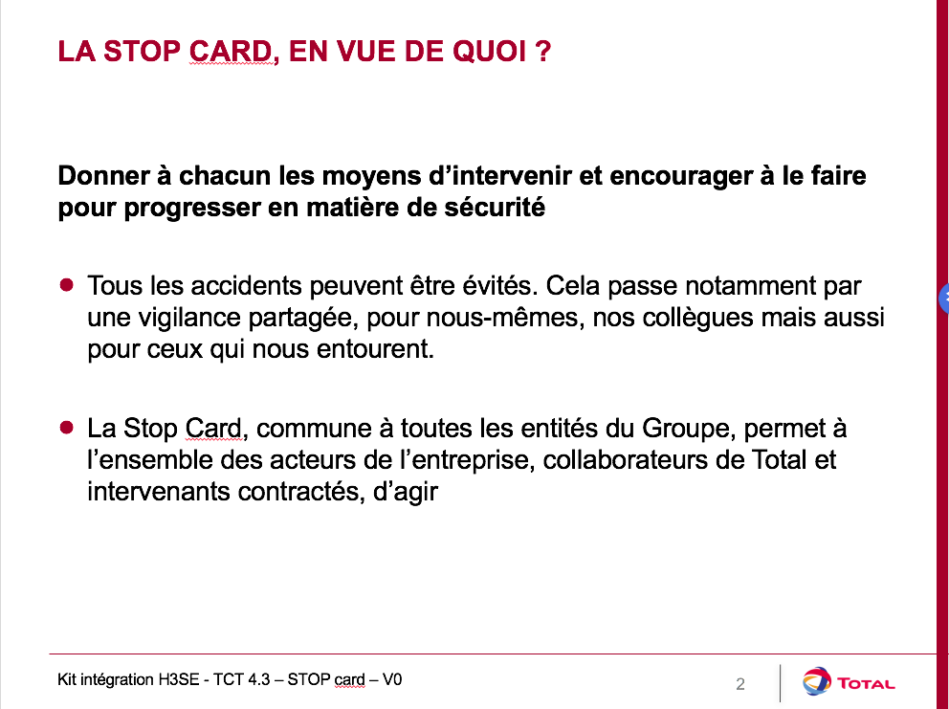  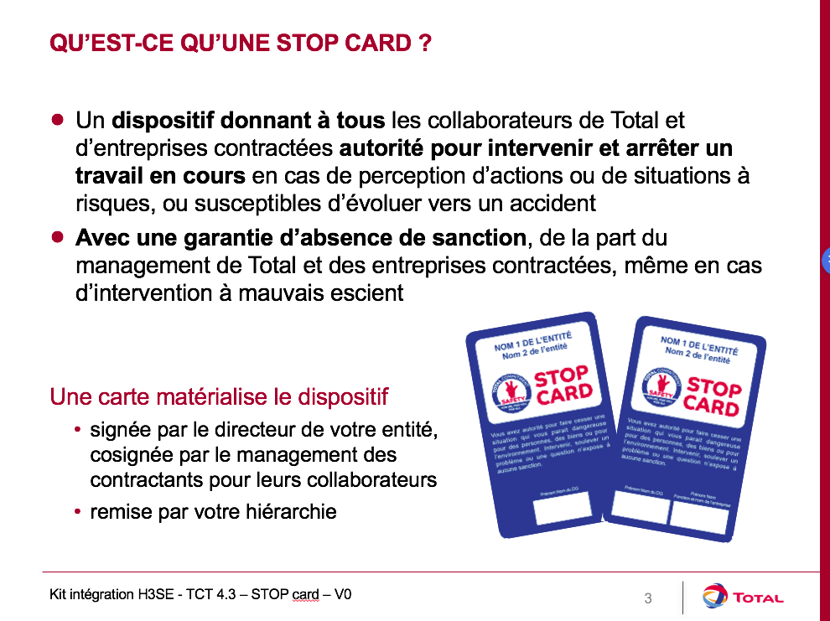  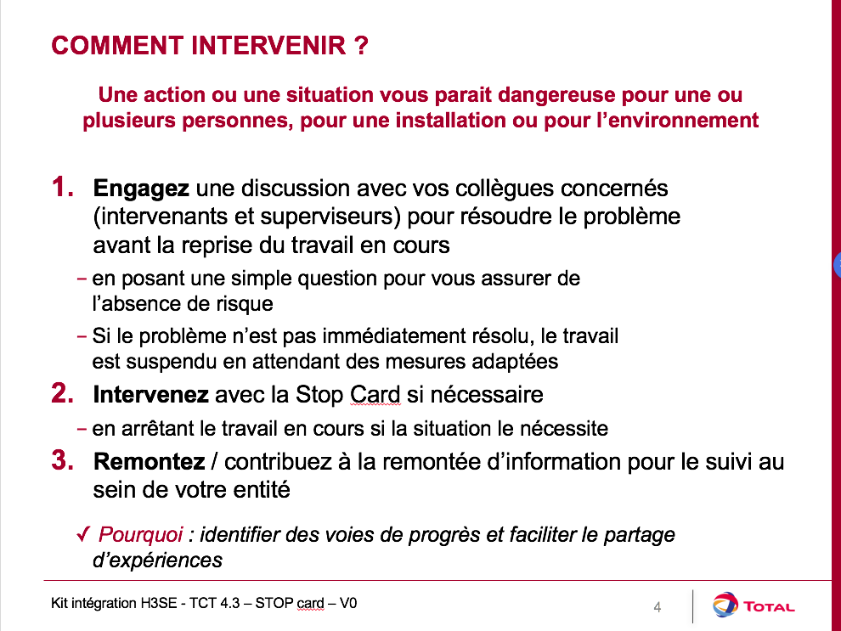
3. Safety observation  5 minutes 20 minutes | To intervene, before using the Stop Card, it is advisable to carry out a safety observation. | What is a safety observation?  It is a simple, open discussion which allows you to (potentially) introduce the Stop Card.  It enables you to make contact with the person by asking them appropriate questions to check that they are aware of the potential risk that they are taking.  Before intervening, you should analyze the context so you can decide on the most appropriate moment to intervene. Depending on the circumstances:  - the intervention must be immediate;  - the intervention may be performed in public, or else in private to avoid the risk of stigmatization.  An intervention must always be conducted in a friendly and open-minded manner.  This means you must always begin by assuming that you have observed or understood the situation incorrectly, and only then should you question the person. It is important to avoid giving the person the impression that they are at fault by using words that will establish mutual respect, which will pave the way for the right questions to be asked.  The guiding principle of an intervention is to investigate the causes of inappropriate behavior and to discuss the consequences of this behavior.
4. Some role plays for safety observation training.  40 minutes 01:00 | Safety observation training  For these simulations, prepare typical cases of anomalies that participants could become involved in.  Use examples of current activity at your site/subsidiary with possible deviations (PPE not suitable or absent, typical risk situation, etc.).  You can also use the illustrations in the Stop Card deployment kit as an example. (StopCard_FPA_Exemples-utilization_FR)  Organize role plays in pairs to get participants involved in making contact and talking about safety (then use the Stop Card, if required).  One person plays the part of the person with whom contact is made, the other is the person who will make contact.  As in module TCT 4.1, I strongly recommend that you practice active listening in this role play.  After each role play, those who observed give their opinion (particularly with regards to the use of active listening) on:  - the positive points for each  - the areas for improvement  Repeat at least once per participant so that they can focus on their positive points and practice implementing the improvements.  If there is only one participant, take a role yourself. | 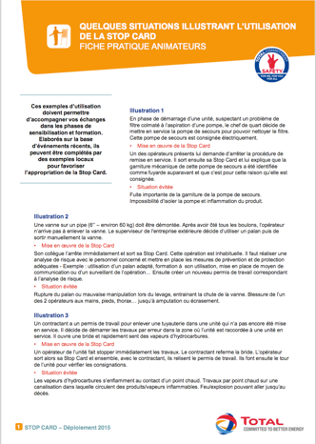
5. Real experience | Put into practice  At the end of the training session, ask participants to commit to applying the safety observation on-site, and to writing a quick discovery report: a short document explaining the situation, the facts, how they did it and how the person reacted.  At the end of the report, participants should write down what surprised them most about this event and what they have taken from it for the future.  A debriefing must then be organized within 6 months of completing the course to share the key points from everyone's discovery report.  In your day-to-day life, you must apply the safety observation and use the Stop Card as soon as you consider it necessary.  Your goal is to achieve at least 10, using the Stop Card only as a last resort, as we have seen.  Once you have completed 10, you will be able to write a "Stop Card discovery report", which we will debrief together.  If the date of the debriefing is known, remind the participants of it. | Contents of the discovery report - Stop Card  Under which circumstances did you (or do you plan to) intervene with the Stop Card?  How did the person react?  What surprised you the most?  What improvements have you made in implementing the safety observation? And in using the Stop Card in general?

