HSE Audit/Site Visit/General Inspection

Objectives:
At the end of the sequence, participants:
- Will be able to take an active part in an HSE audit/a site visit/a general inspection

This sequence is to be built locally. To this end, 2 options are available to you:
- either a local (or branch) training exists and meets these objectives. In this case, it can be used instead of this module.
- if this is not the case, you must build your own training session by following the suggestions below.
This document contains content suggestions and educational activities to achieve the goals of this module.

Key elements | Support/activities
This means involving the newcomer in an audit, a site visit or a general inspection.  The module consists of preparing this audit or visiting for newcomers using the branch's existing documents.  The newcomer must take an active part in the audit (accompanied by an HSE representative from the site/subsidiary) and, if possible, write all or part of the report (a condition for passing the module). | The documents relating to the branch audits (as well as the various "booklets" on the stages of a site visit, such as the one in the Appendix, which can be generalized).  Launch the Moho Nord e-learning: Site visit (00015981)
The site/subsidiary audits and visits are aimed at continuous improvement, not inspection.
Everyone can and must carry out site visits.

Estimated duration:

1 hour in the classroom to prepare followed by the audit (1 day), writing the report and summarizing it.

Teaching method recommendations:
The local manager must organize or make the most of an audit/site visit so that each newcomer can take part in it.

- Pre-requisite modules for the sequence
- TCT 4.1 and TCT 4.3
- Preparing the sequence
For this sequence, you are advised to use the branches' explanatory booklets (take EP's, for example: “Site visit guide”, which is provided in the appendix) presenting the objectives and the teaching methods of the audits/site visits, so you need to ensure that you have a copy for each participant.

The “Site visit” e-learning (00015981) is generic enough to be used in any situation and for all the branches and draws on EP's “Site visit guide” booklet. If you do not have enough PCs available for each participant, you can display it on an overhead projector and teach it interactively.

- Specific important points
The audit in which newcomers must take part should not be a work permit audit or a site compliance visit, which are objectives in the Technical Common Trunk modules (course 3): TCT 3.1 and 3.2.
The participants must play an active part in drafting the audit report and summarizing it. You must plan their role in advance, depending on the type of audit and framework used.

- Suggestion for sequence roll-out
Instructions legend for the trainer:
- Comments for the trainer
- Key content elements
- Type of activity
- “Question to ask”/statement of instructions

Phase/Timing | Trainer | Module content suggestion
1. Moho Nord e-learning  20 minutes 20 minutes | Site/subsidiary visit e-learning  Bring up the Moho Nord e-learning on site/subsidiary visits.  If individual access to a PC is not possible at your site/subsidiary, you can do it online on an overhead projector with the participants and answer the questions like an interactive quiz. | 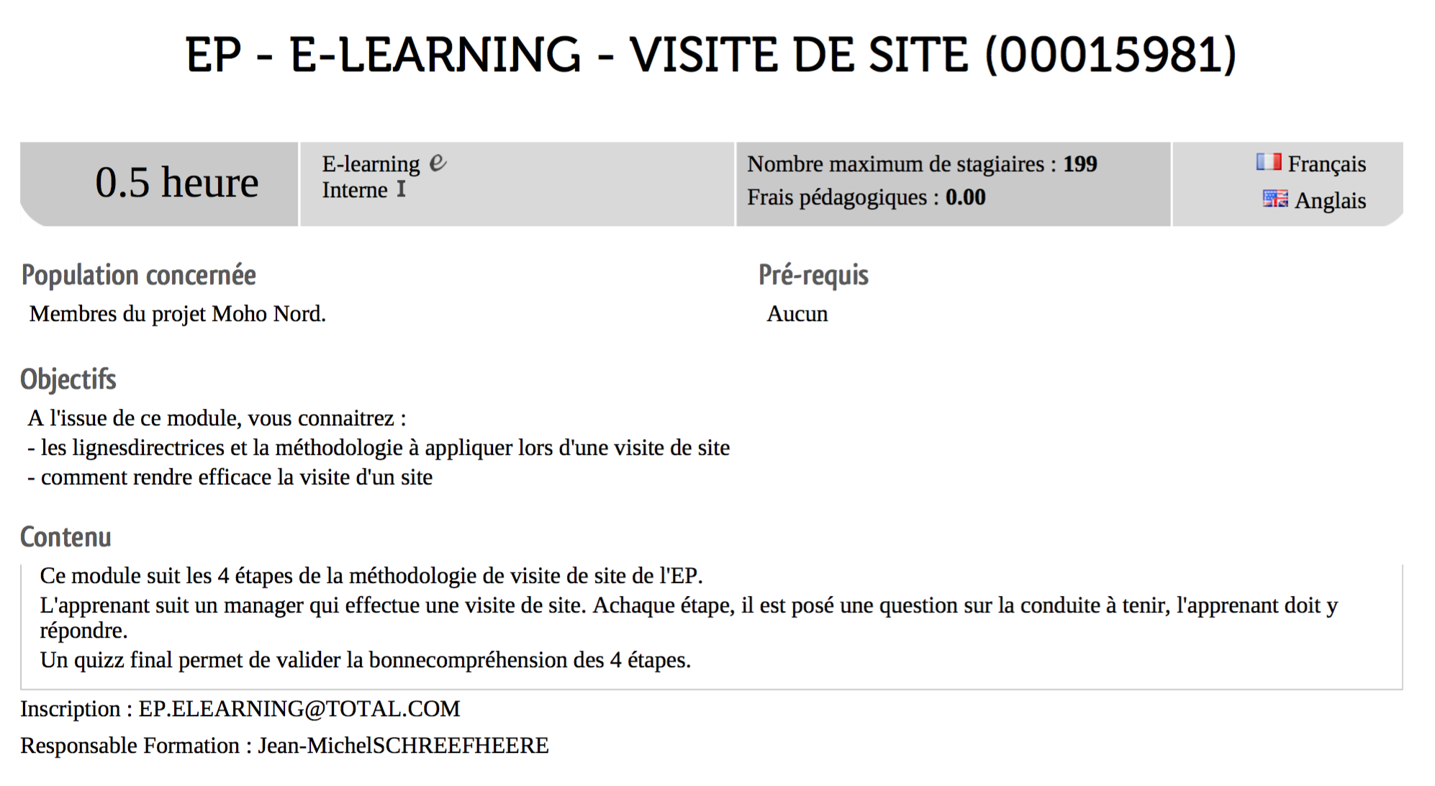
2. Becoming familiar with the audit  40 minutes 01:00 | Audit methodology  Present the methodology of the audit participants are to take part in.  Any type of audit/site-subsidiary visit/HSE field visit, except the Work Permit audit.  Take some time to explain the role that each person will have to play, focusing on an audit framework and expertise formalized in the branch/site/subsidiary guide or framework document.  Key messages to pass along:  The site/subsidiary audits and visits are aimed at continuous improvement, not inspection.  Everyone can and must carry out site visits.  Present participants' role in drafting and summarizing the audit report as well.  Focus on the human factor aspect of the audit, particularly the interviews that will be conducted, reminding them of the human factor module on active listening.  The audit will of course be the opportunity to practice the safety observation and using the Stop Card, as well as active listening during interviews (TCT 4.1 and 4.3).  Schedule for the beginning of the audit/visit | 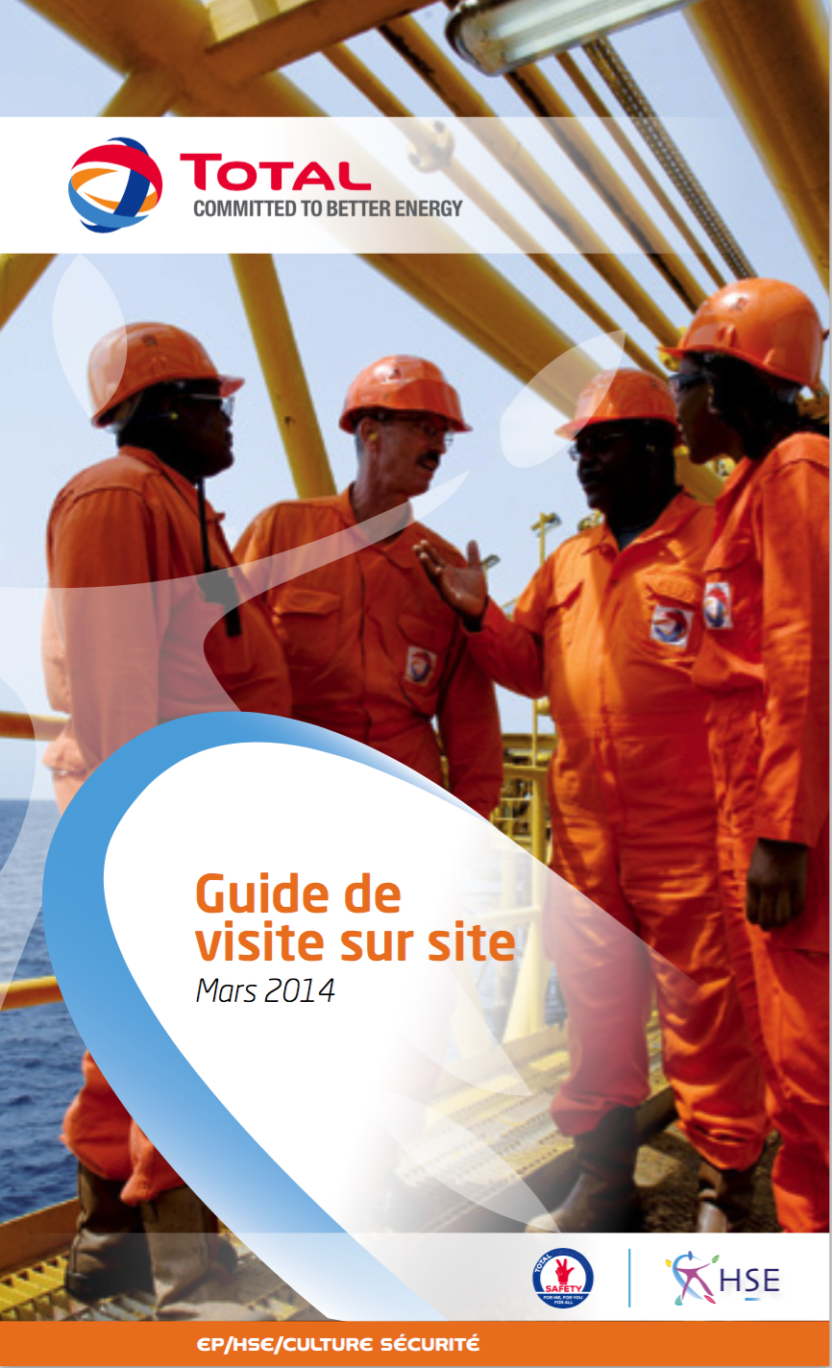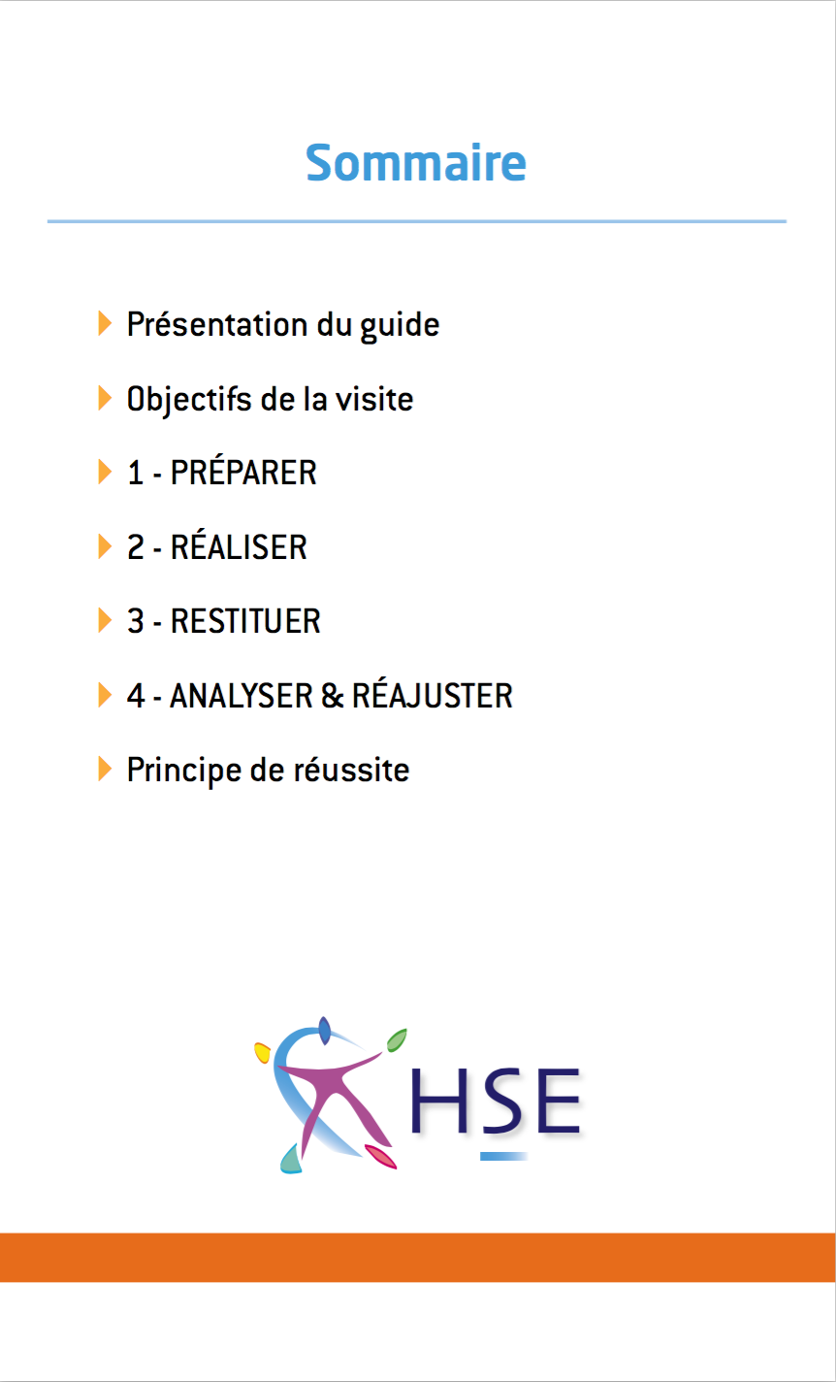  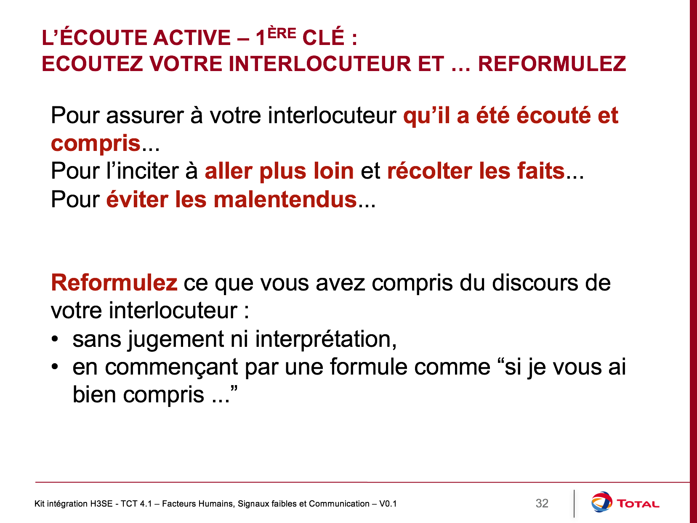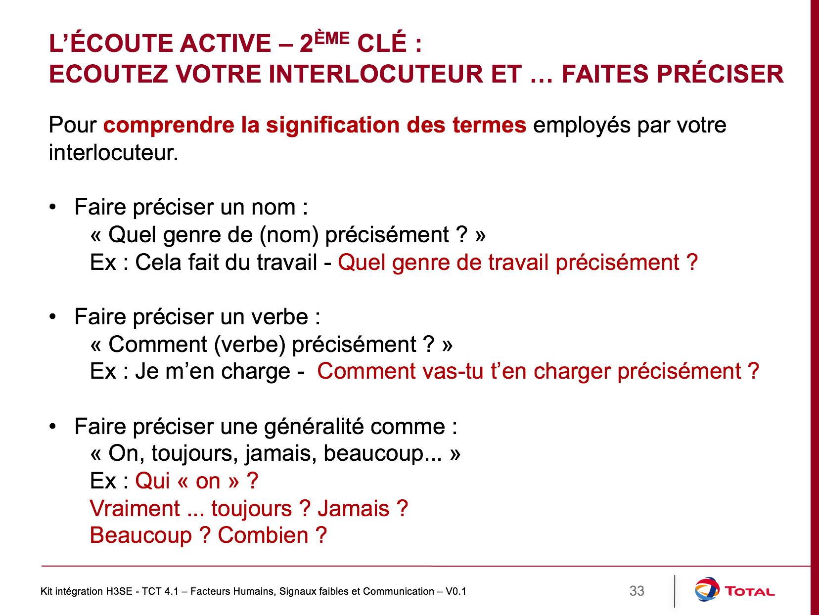
3. Auditing | During the audit, ensure that the participants follow the audit framework and that they play an active part in the audit (interviews in particular).
4. Summarizing the audit | Organize a summary of the audit  Ensure the participants take part in the audit report and that they have a part to present during the report summary.

